Ref. No.: IVM/KBIPER/Ex-Cu/2024-25/01 Date: 9/09/2025

REPORT

01 | Date of activity | 4/09/2025
02 | Total attendance | No.of participated Students: 200  No.of Staff: 40
03 | Occasion of activity | Teachers’ Day Celebration
04. | Objective | To honor and appreciate teachers for their guidance and contribution in shaping students’ lives, while remembering Dr. Sarvepalli Radhakrishnan’s vision of education and nation-building.
05 | Summary Report | On the occasion of Teachers’ Day, celebrated in honor of the late Dr. Sarvepalli Radhakrishnan, KBIPER, Talegaon Dabhade, organized a memorable and joyous event to recognize and appreciate the dedication and guidance of its teaching and non-teaching staff. The celebration commenced with a traditional pooja, conducted by the honorably Nirupa Kanitkar, invoking blessings for the well-being and success of the institution and its members.  The program included the felicitation of all teachers and support staff, acknowledging their tireless efforts in shaping the students’ academic and personal growth. The celebration was meticulously coordinated by Program Coordinator Prof. Shubham Waghmare, ensuring a smooth and engaging flow of events while Prof. A. V. Joshi and Ms.Shweta Mantri addressed the gathering.  Students actively participated in organizing fun activities, games, and singing performances dedicated to their teachers, creating an atmosphere filled with laughter, enthusiasm, and appreciation. These performances not only highlighted the students’ creativity but also strengthened the bond between teachers and students.  The event concluded with a heartfelt vote of thanks delivered by Arote Sir, expressing sincere gratitude to all teachers, staff, and students for their active participation and contribution to the success of the celebration. The Teachers’ Day program at KBIPER was truly a reflection of respect, gratitude, and the vibrant spirit of the institution.
06 | Activity co-coordinator | Mr. S.M.Waghmare  Ms. A.V.Joshi  Ms.Shweta Mantri

Geotag photos of “Teachers day celebration 2025’’
Decoration and stage arrangement | The lamp-lighting ceremony
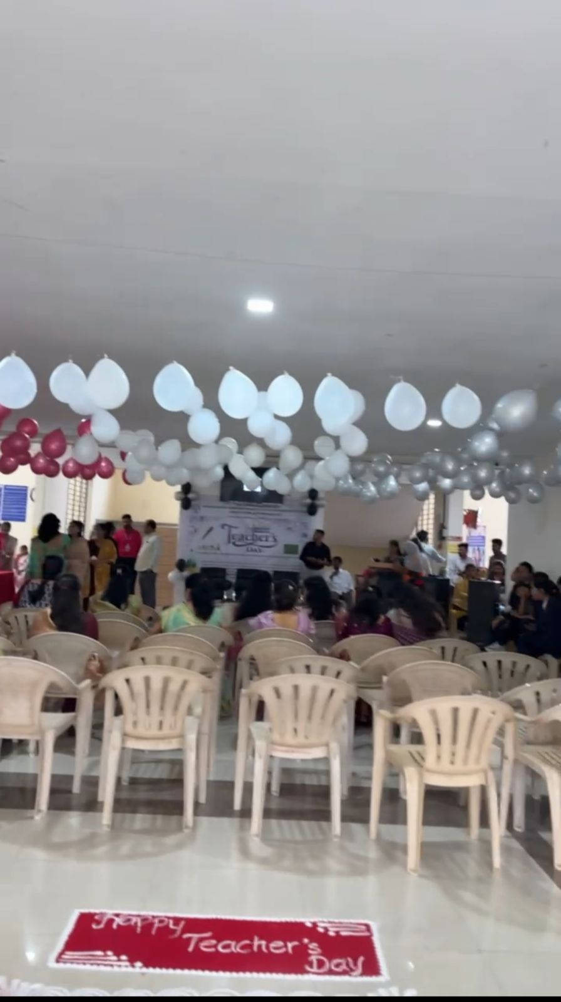  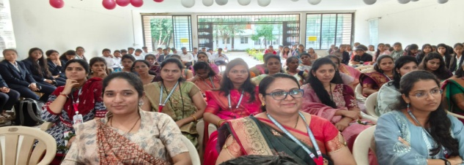 | 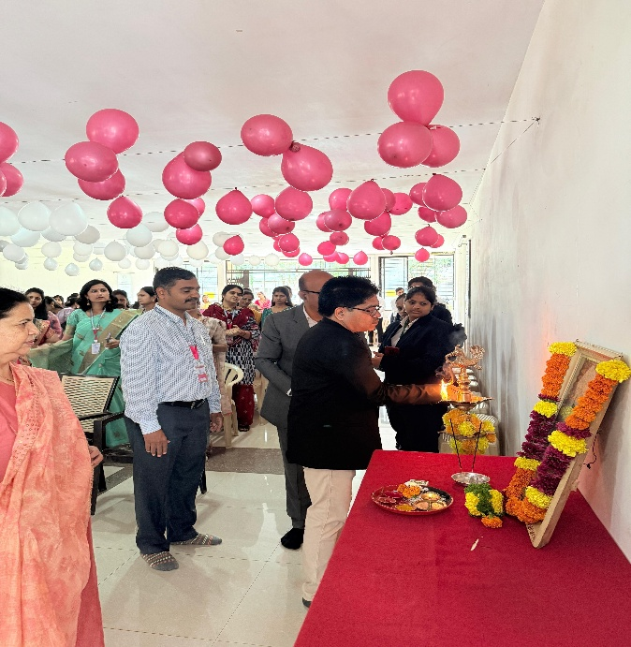  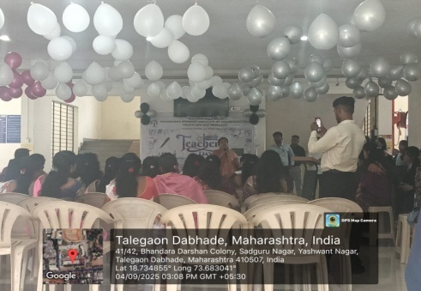
Staff | Honarable Mrs.Nirupa kanitkar mamaddressing the students

Kanitkar Mam speech | Staff felicitation
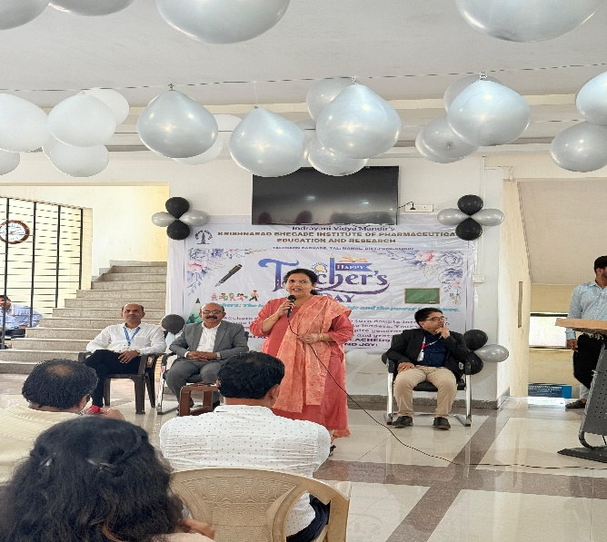 | 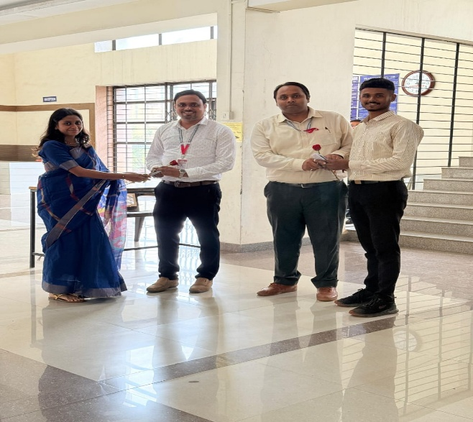
Staff and students during programme | Celebration moment
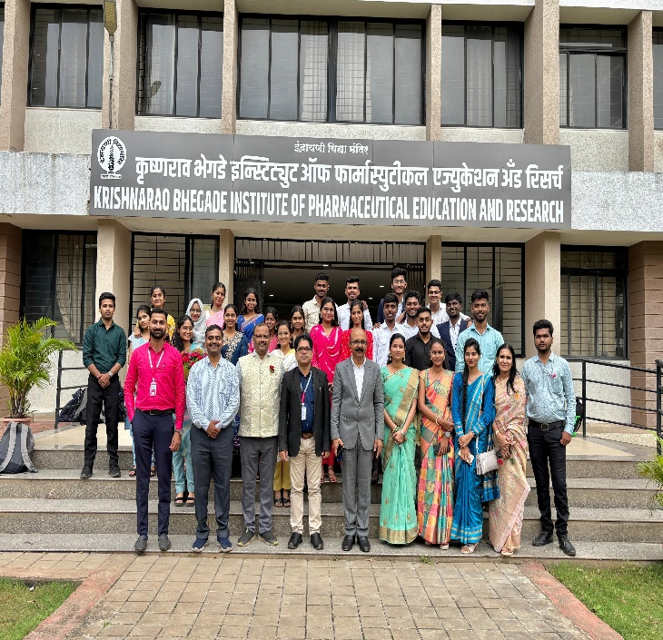 | 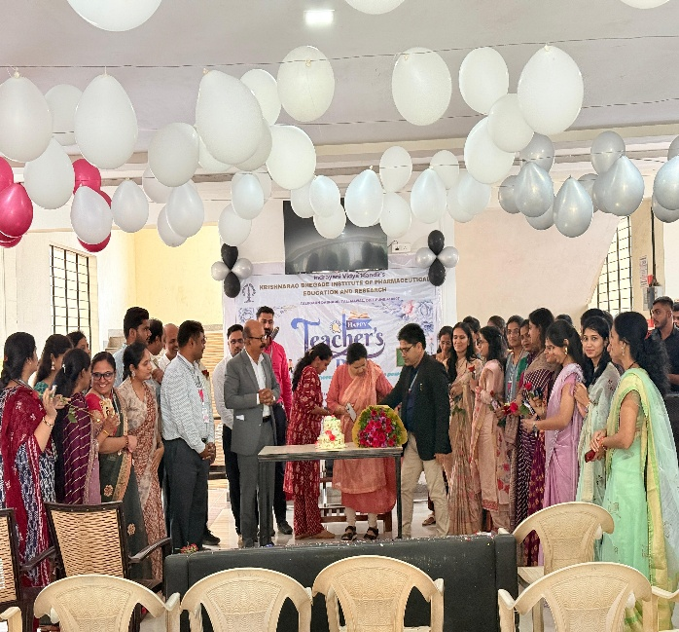

Extracurricular Coordinator IQAC Head HOD Principal
Mr. S.M.Waghmare Dr.Y.B.Zambare Dr.G.S.Shinde Dr. Sanjay R. Arote
Ms. A.V.Joshi
Ms.Shweta Mantri

